UTS Pemograman Web

Aldi Maulana Iqbal – 20210801222

<https://depuuttt.github.io/UTSPemogramanWebSoal/>

## IFrame Capture

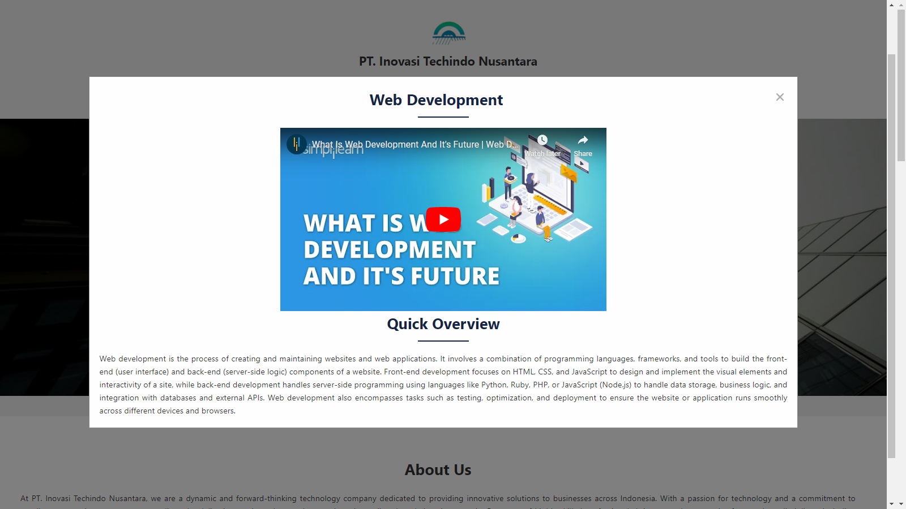

## Form Capture

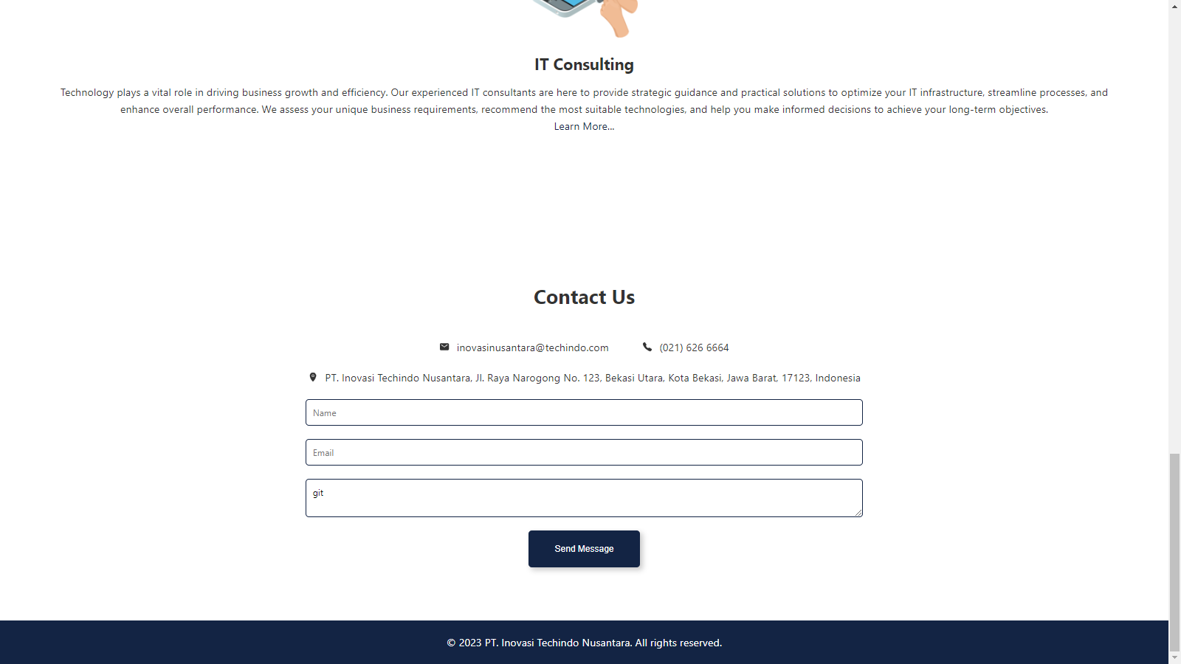

## HTML Source Code

<!DOCTYPE html>

<html lang="en">

  <head>

    <meta charset="UTF-8" />

    <meta name="viewport" content="width=device-width, initial-scale=1.0" />

    <link rel="stylesheet" href="css/style.css" />

    <title>PT. Inovasi Techindo Nusantara</title>

  </head>

  <body>

*<!-- Modal -->*

    <div class="modal" id="modal">

      <div class="modal-content">

        <span class="close"><ion-icon name="close"></ion-icon></span>

        <div class="opening">

          <h2>Welcome to my Midterm Exam project!</h2>

          <hr />

          <p>

            I am pleased to present this project which is the result of my hard

            work and dedication in developing skills in HTML, CSS and

            JavaScript. This project is also a testament to my success in

            completing the Midterm Exams. Through a deep understanding of

            programming languages and web design, I have created innovative and

            attractive solutions. In this project, I have applied concepts

            learned during my university days, such as using HTML for the basic

            structure of web pages, CSS for aesthetic appearance and layout, and

            JavaScript for dynamic interactivity. I hope that this project will

            reflect my progress and be the first step in my journey as a

            competent web developer.

          </p>

        </div>

        <div class="about-me">

          <h2>About Me</h2>

          <hr />

          <div class="profile-group">

            <div class="profile-point">

              <strong>Nama</strong>

              <p>Aldi Maulana Iqbal</p>

            </div>

            <div class="profile-point">

              <strong>NIM</strong>

              <p>20210801222</p>

            </div>

            <div class="profile-point">

              <strong>Jurusan</strong>

              <p>Teknik Informatika</p>

            </div>

          </div>

          <div class="profile-group">

            <div class="profile-point">

              <a href="https://github.com/depuuttt" target="_blank"

                ><ion-icon name="logo-github" size="large"></ion-icon

              ></a>

            </div>

            <div class="profile-point">

              <a

                href="https://www.linkedin.com/in/aldi-maulana-98058b158"

                target="_blank"

                ><ion-icon name="logo-linkedin" size="large"></ion-icon

              ></a>

            </div>

          </div>

        </div>

      </div>

    </div>

*<!-- Header -->*

    <header>

      <nav>

        <div class="logo">

          <a href="#"

            ><img src="img/logo.png" alt="PT. Inovasi Techindo Nusantara logo"

          /></a>

          <p>PT. Inovasi Techindo Nusantara</p>

        </div>

        <ul class="nav-links">

          <li><a href="#about-us">About</a></li>

          <li><a href="#services">Services</a></li>

          <li><a href="#contacts">Contact</a></li>

        </ul>

      </nav>

      <div class="hero-text">

        <h1>Welcome to PT. Inovasi Techindo Nusantara</h1>

        <p>We provide innovative solutions for your technological needs.</p>

        <a class="cta-button" href="#about-us">Get Started</a>

      </div>

    </header>

*<!-- About Us -->*

    <section class="about" id="about-us">

      <div class="about-text">

        <h2>About Us</h2>

        <p>

          At PT. Inovasi Techindo Nusantara, we are a dynamic and

          forward-thinking technology company dedicated to providing innovative

          solutions to businesses across Indonesia. With a passion for

          technology and a commitment to excellence, we strive to empower our

          clients by delivering cutting-edge products and services tailored to

          their unique needs. Our team of highly skilled professionals brings

          together expertise from various disciplines, including software

          development, data analytics, artificial intelligence, and

          cybersecurity. We believe in the power of collaboration and constantly

          push the boundaries of what is possible to create impactful solutions

          that drive business growth and efficiency. As a trusted partner, we

          understand the challenges faced by businesses in today's rapidly

          evolving digital landscape. That's why we work closely with our

          clients to gain a deep understanding of their goals, processes, and

          pain points. By leveraging our technical expertise and industry

          insights, we develop custom solutions that address their specific

          requirements, helping them stay ahead of the competition and achieve

          sustainable success.

        </p>

      </div>

    </section>

*<!-- Services -->*

    <section class="services" id="services">

      <h2>Our Services</h2>

      <div class="service-card">

        <div class="service-icon">

          <img src="img/services1.png" alt="Service 1" />

        </div>

        <h3>Web Development</h3>

        <p>

          Our skilled web developers combine creativity, functionality, and user

          experience to create stunning websites tailored to your business

          needs. Whether you require a simple informational website or a complex

          e-commerce platform, we employ the latest technologies and best

          practices to deliver robust and scalable web solutions.

        </p>

        <a href="#" id="openModalWeb">Learn More...</a>

        <div class="modal" id="modalWeb">

          <div class="modal-content">

            <span class="close closeWeb"

              ><ion-icon name="close"></ion-icon

            ></span>

            <div class="opening">

              <h2>Web Development</h2>

              <hr />

              <div class="yt-vids">

                <iframe

                  src="https://www.youtube.com/embed/xGmIl7QbBiA"

                  frameborder="0"

                  allowfullscreen

                ></iframe>

              </div>

              <div class="yt-desc">

                <h2>Quick Overview</h2>

                <hr />

                <p>

                  Web development is the process of creating and maintaining

                  websites and web applications. It involves a combination of

                  programming languages, frameworks, and tools to build the

                  front-end (user interface) and back-end (server-side logic)

                  components of a website. Front-end development focuses on

                  HTML, CSS, and JavaScript to design and implement the visual

                  elements and interactivity of a site, while back-end

                  development handles server-side programming using languages

                  like Python, Ruby, PHP, or JavaScript (Node.js) to handle data

                  storage, business logic, and integration with databases and

                  external APIs. Web development also encompasses tasks such as

                  testing, optimization, and deployment to ensure the website or

                  application runs smoothly across different devices and

                  browsers.

                </p>

              </div>

            </div>

          </div>

        </div>

      </div>

      <div class="service-card">

        <div class="service-icon">

          <img src="img/services2.png" alt="Service 2" />

        </div>

        <h3>Mobile App Development</h3>

        <p>

          In a world dominated by smartphones, having a mobile app for your

          business is essential to reach and engage with your target audience

          effectively. Our mobile app development team excels in building native

          and cross-platform apps that deliver seamless experiences across

          various devices. From concept to deployment, we guide you through the

          entire app development lifecycle to ensure your app stands out in the

          app stores.

        </p>

        <a href="#" id="openModalMobile">Learn More...</a>

        <div class="modal" id="modalMobile">

          <div class="modal-content">

            <span class="close closeMobile"

              ><ion-icon name="close"></ion-icon

            ></span>

            <div class="opening">

              <h2>Mobile App Development</h2>

              <hr />

              <div class="yt-vids">

                <iframe

                  src="https://www.youtube.com/embed/WvwwL0TwH6U"

                  frameborder="0"

                  allowfullscreen

                ></iframe>

              </div>

              <div class="yt-desc">

                <h2>Quick Overview</h2>

                <hr />

                <p>

                  Mobile app development is the process of creating software

                  applications for mobile devices such as smartphones and

                  tablets. It involves several stages, including ideation,

                  design, development, testing, and deployment. Developers use

                  programming languages and frameworks like Java, Swift, or

                  React Native to build apps for specific operating systems such

                  as iOS or Android. Key considerations in app development

                  include user experience (UX) design, functionality,

                  performance optimization, and security. Additionally, app

                  development may involve integrating features like push

                  notifications, in-app purchases, or social media sharing. Once

                  the app is developed, it goes through rigorous testing to

                  ensure its stability and usability. Finally, the app is

                  published to respective app stores, and developers often

                  provide updates and maintenance to improve the app over time.

                </p>

              </div>

            </div>

          </div>

        </div>

      </div>

      <div class="service-card">

        <div class="service-icon">

          <img src="img/services3.png" alt="Service 3" />

        </div>

        <h3>IT Consulting</h3>

        <p>

          Technology plays a vital role in driving business growth and

          efficiency. Our experienced IT consultants are here to provide

          strategic guidance and practical solutions to optimize your IT

          infrastructure, streamline processes, and enhance overall performance.

          We assess your unique business requirements, recommend the most

          suitable technologies, and help you make informed decisions to achieve

          your long-term objectives.

        </p>

        <a href="#" id="openModalConsul">Learn More...</a>

        <div class="modal" id="modalConsul">

          <div class="modal-content">

            <span class="close closeConsul"

              ><ion-icon name="close"></ion-icon

            ></span>

            <div class="opening">

              <h2>IT Consulting</h2>

              <hr />

              <div class="yt-vids">

                <iframe

                  src="https://www.youtube.com/embed/gTdDH6T5kaE"

                  frameborder="0"

                  allowfullscreen

                ></iframe>

              </div>

              <div class="yt-desc">

                <h2>Quick Overview</h2>

                <hr />

                <p>

                  IT consulting refers to the practice of providing expert

                  advice and assistance to organizations in utilizing

                  information technology to achieve their business objectives.

                  IT consultants analyze the client's existing IT

                  infrastructure, identify areas for improvement, and propose

                  strategies to enhance efficiency, productivity, and security.

                  They offer guidance on technology solutions, system

                  integration, software implementation, and digital

                  transformation initiatives, tailoring recommendations to meet

                  the specific needs and goals of each client. IT consulting

                  also involves evaluating risks, managing projects, and

                  providing ongoing support and maintenance, ensuring that

                  businesses effectively leverage technology to gain a

                  competitive edge in today's digital landscape.

                </p>

              </div>

            </div>

          </div>

        </div>

      </div>

    </section>

*<!-- Contact Us -->*

    <section class="contact" id="contacts">

      <h2>Contact Us</h2>

      <div class="contact-group">

        <div class="contact-point">

          <ion-icon name="mail"></ion-icon>

          <p>inovasinusantara@techindo.com</p>

        </div>

        <div class="contact-point">

          <ion-icon name="call"></ion-icon>

          <p>(021) 626 6664</p>

        </div>

      </div>

      <div class="contact-group">

        <div class="contact-point">

          <ion-icon name="location"></ion-icon>

          <p>

            PT. Inovasi Techindo Nusantara, Jl. Raya Narogong No. 123, Bekasi

            Utara, Kota Bekasi, Jawa Barat, 17123, Indonesia

          </p>

        </div>

      </div>

      <form name="messageForm" id="messageForm" method="post">

        <input type="text" placeholder="Name" />

        <input type="email" placeholder="Email" />

        <textarea placeholder="Message"></textarea>

        <button type="submit" name="submit" id="submit">Send Message</button>

      </form>

    </section>

    <footer>

      <p>&copy; 2023 PT. Inovasi Techindo Nusantara. All rights reserved.</p>

    </footer>

    <script src="js/jquery-3.7.0.min.js"></script>

    <script src="js/smoothscroll.js"></script>

    <script src="js/script.js"></script>

    <script

      type="module"

      src="https://unpkg.com/ionicons@7.1.0/dist/ionicons/ionicons.esm.js"

    ></script>

    <script

      nomodule

      src="https://unpkg.com/ionicons@7.1.0/dist/ionicons/ionicons.js"

    ></script>

  </body>

</html>

## CSS Source Code

*/* Reset styles */*

html {

  scroll-behavior: smooth;

}

* {

  margin: 0;

  padding: 0;

  box-sizing: border-box;

}

*/* Global styles */*

body {

  font-family: "Segoe UI", Tahoma, Geneva, Verdana, sans-serif;

  line-height: 1.6;

  color: #333;

}

.container {

  max-width: 1200px;

  margin: 0 auto;

  padding: 0 20px;

}

*/* Header */*

header {

  background: #f1f1f1;

  padding: 40px 0;

  text-align: center;

}

.logo {

  font-size: 24px;

  font-weight: bold;

}

.nav-links {

  list-style: none;

  margin-top: 20px;

}

.nav-links li {

  display: inline-block;

  margin: 0 10px;

}

.nav-links a {

  text-decoration: none;

  color: #333;

}

.hero-text {

  margin-top: 50px;

  color: white;

  padding: 10vw;

  background-image: url("../img/background.jpg");

  background-size: cover;

  background-repeat: no-repeat;

  background-position: center;

  background-attachment: fixed;

  text-shadow: 0 2px 4px rgba(0, 0, 0, 0.2), 0 4px 8px rgba(0, 0, 0, 0.2);

}

.hero-text h1 {

  font-size: 36px;

  margin-bottom: 20px;

}

.cta-button {

  margin: 20px 0;

  display: inline-block;

  padding: 10px 20px;

  background-color: rgba(31, 48, 81, 0.5);

  color: #fff;

  text-decoration: none;

  border-radius: 10px;

}

.cta-button:hover {

  transition: all 0.3s ease-in;

  background: rgba(31, 48, 81, 1);

}

*/* About section */*

.about {

  display: flex;

  align-items: center;

  padding: 80px 40px;

}

.about-text {

  flex: 1;

  padding-right: 40px;

  text-align: justify;

}

.about-text h2 {

  text-align: center;

  font-size: 30px;

  margin-bottom: 20px;

}

.about-image img {

  width: 100%;

  max-width: 400px;

}

*/* Services section */*

.services {

  text-align: center;

  padding: 80px 40px;

}

.services h2 {

  font-size: 30px;

  margin-bottom: 40px;

}

.service-card {

  display: flex;

  align-items: center;

  justify-content: center;

  flex-direction: column;

  padding: 20px;

  margin-bottom: 40px;

}

.service-card a {

  position: relative;

  text-decoration: none;

  color: #132444;

  transition: all 0.5s ease-in;

}

.service-card a:active {

  color: #132444;

}

.service-card a::after {

  content: "";

  position: absolute;

  left: 0;

  bottom: -2px;

  width: 100%;

  height: 2px;

  background-color: #000;

  transform: scaleX(0);

  transition: transform 0.3s ease;

}

.service-card a:hover::after {

  transform: scaleX(1);

}

.service-card .yt-vids {

  display: flex;

  justify-content: center;

}

.service-card .yt-vids iframe {

  width: 640px;

  height: 360px;

}

.service-icon {

  display: block;

  width: 160px;

  height: 160px;

  margin-bottom: 20px;

}

.service-icon img {

  transition: transform 0.3s ease, opacity 0.3s ease;

}

.service-icon img:hover {

  transform: scale(1.1);

  opacity: 0.9;

}

.service-card h3 {

  font-size: 24px;

  margin-bottom: 10px;

}

*/* Contact section */*

.contact {

  text-align: center;

  padding: 80px 40px;

}

.contact h2 {

  font-size: 30px;

  margin-bottom: 40px;

}

.contact-group {

  display: flex;

  align-items: center;

  justify-content: center;

  margin: 20px 0;

}

.contact-group .contact-point {

  display: flex;

  align-items: center;

  margin: 0 20px;

}

.contact-group .contact-point ion-icon,

.contact-group .contact-point p {

  margin: 0 5px;

}

.contact form input,

.contact form textarea {

  font-family: "Segoe UI", Tahoma, Geneva, Verdana, sans-serif;

  display: block;

  width: 50%;

  padding: 10px;

  margin: auto;

  margin-bottom: 20px;

  border: 2px solid #132444;

  text-decoration: none;

  border-radius: 5px;

}

.contact form input:focus,

.contact form textarea:focus {

  transition: all 0.3s ease-in;

  border: 2px solid #132444;

  box-shadow: 0 2px 4px rgba(0, 0, 0, 0.2), 0 4px 8px rgba(0, 0, 0, 0.1);

}

.contact form input:focus::placeholder,

.contact form textarea:focus::placeholder,

.contact form input:placeholder-shown,

.contact form textarea:placeholder-shown {

  transition: all 0.3s ease-in;

  color: transparent;

}

.contact form button {

  display: inline-block;

  padding: 20px 40px;

  background: #132444;

  color: #fff;

  text-decoration: none;

  border: none;

  border-radius: 5px;

  box-shadow: 4px 4px 8px rgba(0, 0, 0, 0.2),

    -4px -4px 8px rgba(255, 255, 255, 0.5);

  cursor: pointer;

}

.contact form button:hover {

  transition: all 0.5s ease-out;

  background: #315476;

}

*/* Footer */*

footer {

  background: #132444;

  color: #fff;

  text-align: center;

  padding: 20px 0;

}

footer p {

  margin-bottom: 0;

}

*/* Modal */*

.modal {

  display: none;

  position: fixed;

  z-index: 1;

  left: 0;

  top: 0;

  width: 100%;

  height: 100%;

  overflow: auto;

  background-color: rgba(0, 0, 0, 0.5);

}

.modal h2 {

  font-size: 30px;

  margin-bottom: 10px;

  color: #132444;

  text-align: center;

}

.modal hr {

  border: none;

  border-top: 3px solid #132444;

  margin: auto;

  margin-bottom: 20px;

  width: 100px;

}

.modal-content {

  background-color: #fefefe;

  margin: 15% auto;

  padding: 20px;

  border: 1px solid #888;

  width: 80%;

  text-align: justify;

}

.modal-content .about-me .profile-group {

  display: flex;

  justify-content: center;

  margin-bottom: 20px;

}

.modal-content .about-me .profile-point {

  margin: 0 20px;

}

.modal-content .about-me .profile-point a {

  color: #132444;

  transition: all 0.3s ease-in;

}

.modal-content .about-me .profile-point a:hover {

  opacity: 0.8;

}

.close {

  color: #aaa;

  float: right;

  font-size: 28px;

  font-weight: bold;

  cursor: pointer;

  transition: all 0.3s ease-in;

}

.close:hover,

.close:focus {

  color: black;

  text-decoration: none;

}

.fade-in {

  animation: fadeIn 0.5s;

}

.fade-out {

  animation: fadeOut 0.5s;

}

@keyframes fadeIn {

  from {

    opacity: 0;

  }

  to {

    opacity: 1;

  }

}

@keyframes fadeOut {

  from {

    opacity: 1;

  }

  to {

    opacity: 0;

  }

}

## Javascript Source Code

*// Opening Modal*

document.addEventListener("DOMContentLoaded", function () {

  var modal = document.getElementById("modal");

  function showModal() {

    modal.style.display = "block";

    modal.classList.add("fade-in");

  }

  function hideModal() {

    modal.classList.add("fade-out");

    setTimeout(function () {

      modal.style.display = "none";

      modal.classList.remove("fade-in", "fade-out");

    }, 500);

  }

  setTimeout(showModal, 600);

  var closeBtn = document.getElementsByClassName("close")[0];

  closeBtn.addEventListener("click", hideModal);

  window.addEventListener("click", function (event) {

    if (event.target === modal) {

      hideModal();

    }

  });

});

*// Web Development Modal*

var modalWeb = document.getElementById("modalWeb");

var openBtnWeb = document.getElementById("openModalWeb");

var closeBtnWeb = document.getElementsByClassName("closeWeb")[0];

openBtnWeb.onclick = function() {

  modalWeb.style.display = "block";

  modalWeb.classList.add("fade-in");

};

closeBtnWeb.onclick = function() {

  modalWeb.style.display = "none";

  modalWeb.classList.add("fade-out");

};

window.onclick = function(event) {

  if (event.target == modalWeb) {

    modalWeb.style.display = "none";

  }

};

*// Mobile App Development Modal*

var modalMobile = document.getElementById("modalMobile");

var openBtnMobile = document.getElementById("openModalMobile");

var closeBtnMobile = document.getElementsByClassName("closeMobile")[0];

openBtnMobile.onclick = function() {

  modalMobile.style.display = "block";

  modalMobile.classList.add("fade-in");

};

closeBtnMobile.onclick = function() {

  modalMobile.style.display = "none";

  modalMobile.classList.add("fade-out");

};

window.onclick = function(event) {

  if (event.target == modalMobile) {

    modalMobile.style.display = "none";

  }

};

*// IT Consultant Modal*

var modalConsul = document.getElementById("modalConsul");

var openBtnConsul = document.getElementById("openModalConsul");

var closeBtnConsul = document.getElementsByClassName("closeConsul")[0];

openBtnConsul.onclick = function() {

  modalConsul.style.display = "block";

  modalConsul.classList.add("fade-in");

};

closeBtnConsul.onclick = function() {

  modalConsul.style.display = "none";

  modalConsul.classList.add("fade-out");

};

window.onclick = function(event) {

  if (event.target == modalConsul) {

    modalConsul.style.display = "none";

  }

};